**PARISHAY CROCHET COLLECTION (WEBSITE DESIGN)**

**SUBMITTED BY : AREEBA NAZ**

**COURSE : WAD**

**SUBMITTED TO : DR. KAHALID SALEEM**

**DATE OF SUBMISSION : 9TH MAY,2024**

**QUAID -E- AZAM UNIVERSITY, ISLAMABAD**

Table of Contents

1. TITLE : 3

2. MISSION STATEMENT: 3

3. Project motivation: 3

4. Who, what, where.. 3

5. Audience: 3

6. Mind Map: 4

7. Site Map: 4

8. Low Fidelity mockup: 5

9. High fidelity Mockup: 7

**TOPIC: WEBSITE DESIGN DOCUMENT**

# TITLE :

The name of the website is “PARISHAY CROCHET COLLECTION”. The proposed URL for this website will be www.parishaycrochetcollection.com.

# MISSION STATEMENT:

The mission statement for this website is as follow:

“Our mission is to provide a diverse selection of high-quality crochet accessories through our website. I am dedicated to meeting the needs of our customers by offering a range of products and welcoming custom requests. Our goal is to be a convenient and trusted destination where customers can find unique and stylish accessories all in one place.”

# Project motivation:

This website is a unique idea as it provides services and allow customers to buy crochet accessories in just one place such as bags, jewelry, clothes, sweaters ,home decors.

Some other websites also provide these services but the accessories are not categories well which create difficulties for the user. So the main objective is to create a website that is user friendly.

# Who, what, where..

**Who:**

Customers who want to buy hand-made crochet accessories.

**What:**

Because it’s a unique idea and people like to wear crochet accessories.

**Where:**

other web sites that buy and sell crochet accessories.

**When:**

When people visit the website through social media.

**Why:**

To let the user search the items and accessories by categories.

**How?**

By selecting categories, a related list will be shown and by clicking all details will be shown.

**Huh?**

It’s a unique idea. I personally love it. It will be useful for others too.

# Audience:

The audience and customers include both male and female age greater than 18 that are eligible to buy things online. This website attracts the audience who love to wear /use handmade crochet accessories. These accessories include bags, purses, scarves & shawls, hats & gloves , jewelry, socks & slippers ,hair accessories.

# Mind Map:

# Site Map:

# Low Fidelity mockup:

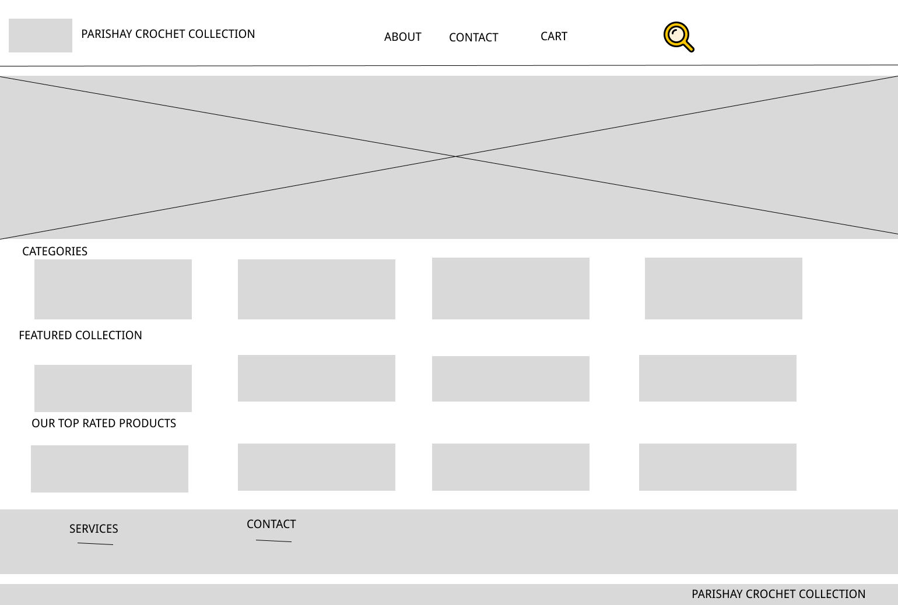

Fig 1 Desktop -Homepage

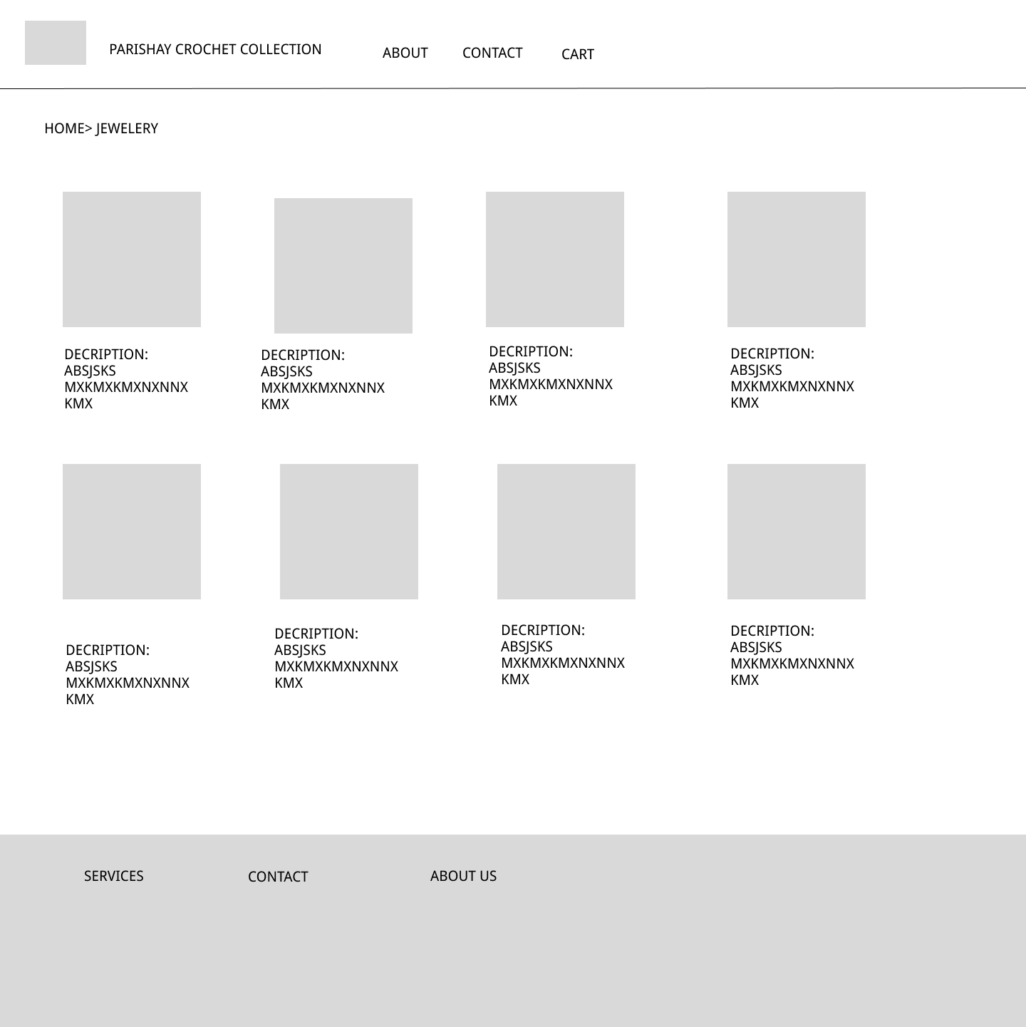

# High fidelity Mockup:

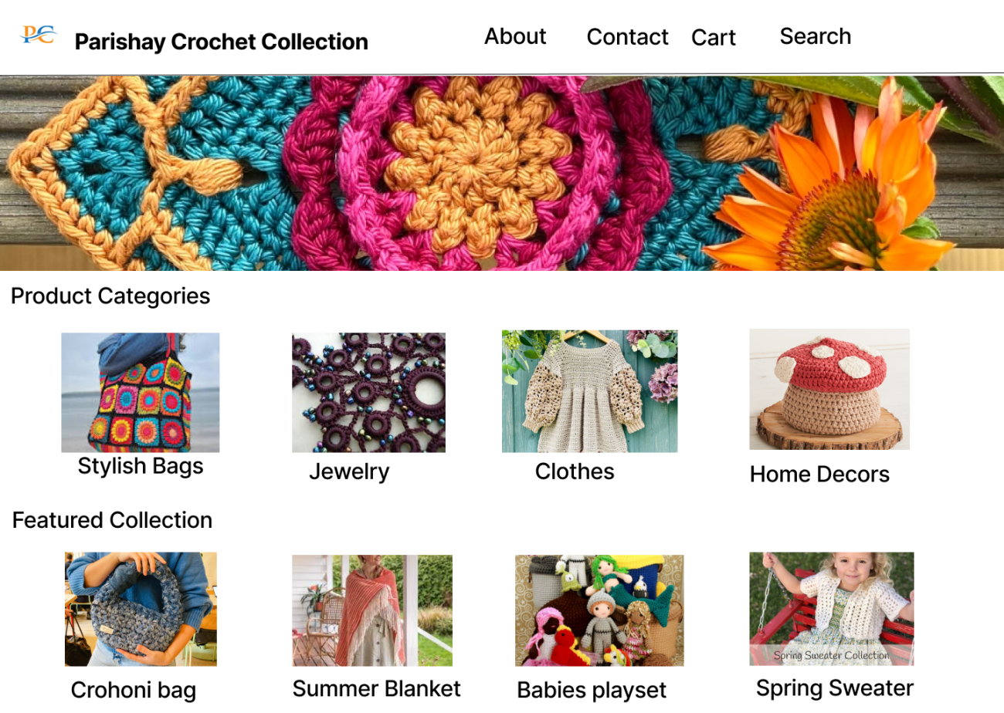

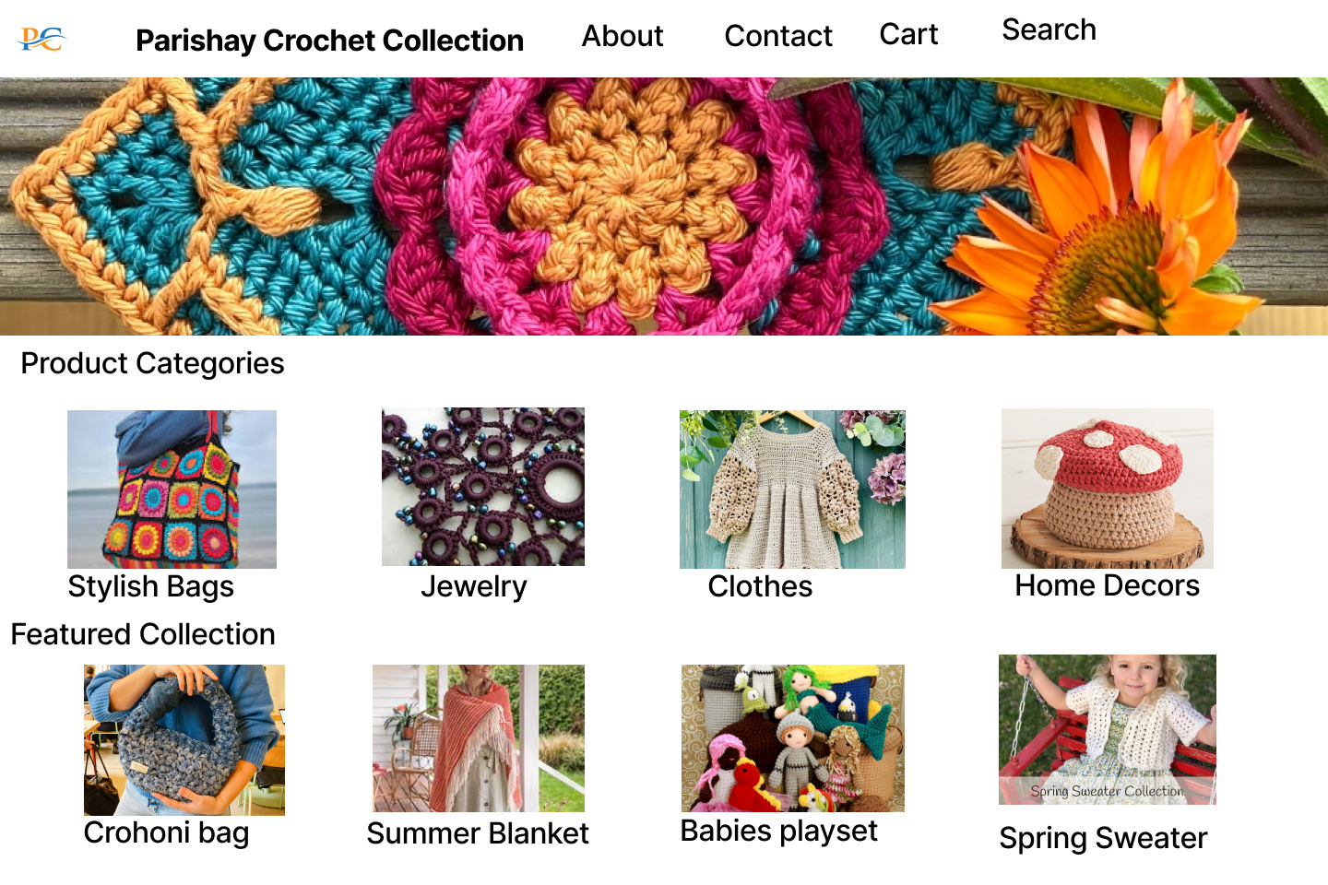 Fig Desktop -1

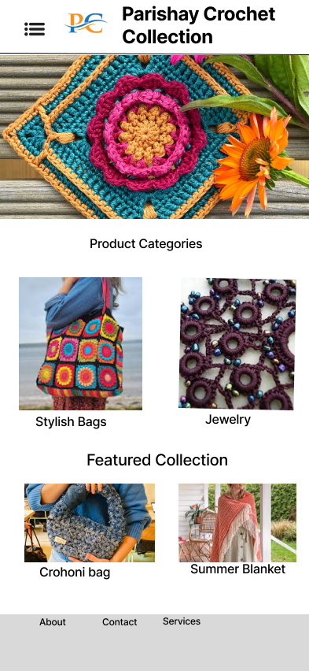

Fig iPhone 14 or 15

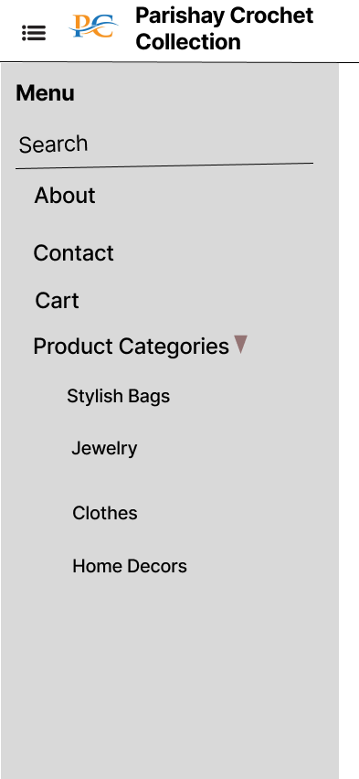

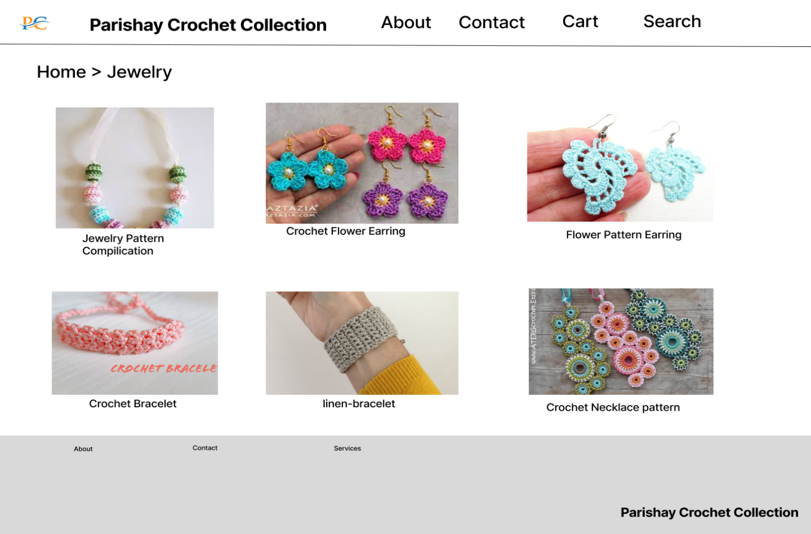 Fig Surface Pro 8 -HomePage